Percentail Assignment

Placement Dataset: Average Percentage for SSC, HSC, Degree, E-test, MBA, and Salary. We analyze the data at 25%, 50%, 75%, and 100% levels to check the differences and improvements between each percentage interval.
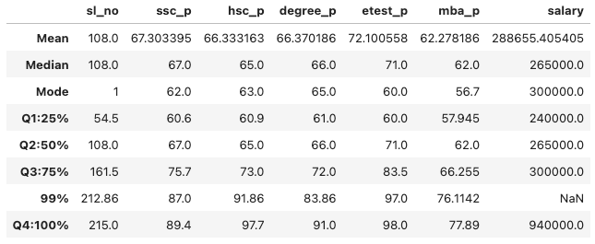

First Set (25%):
SSC 60.6%, HSC 60.9%, Degree 61%, E-test 60%, MBA 57.94%
Average Salary: 2.4 lakhs
Second Set (25%):
SSC 67%, HSC 65%, Degree 66%, E-test 71%, MBA 62%
Average Salary: 2.6 lakhs
Growth from 25% to 50% (Next 25% Placement Data):
SSC growth 7%, HSC growth 5%, Degree growth 5%, E-test growth 11%, MBA growth 5%, Salary growth 8.33%

Third Set (25%):
SSC 75.7%, HSC 73%, Degree 72%, E-test 83.5%, MBA 66.2%
Average Salary: 3 lakhs
Growth from 50% to 75% (Next 25% Placement Data):
SSC growth 8.7%, HSC growth 8%, Degree growth 6%, E-test growth 12.5%, MBA growth 4%, Salary growth 15.38%
Fourth Set (25%):
SSC 89.4%, HSC 97.7%, Degree 91%, E-test 98%, MBA 77%
Average Salary: 9.4 lakhs
Growth from 75% to 100% (Next 25% Placement Data):
SSC growth 14%, HSC growth 25%, Degree growth 19%, E-test growth 15%, MBA growth 11%, Salary growth 213%

